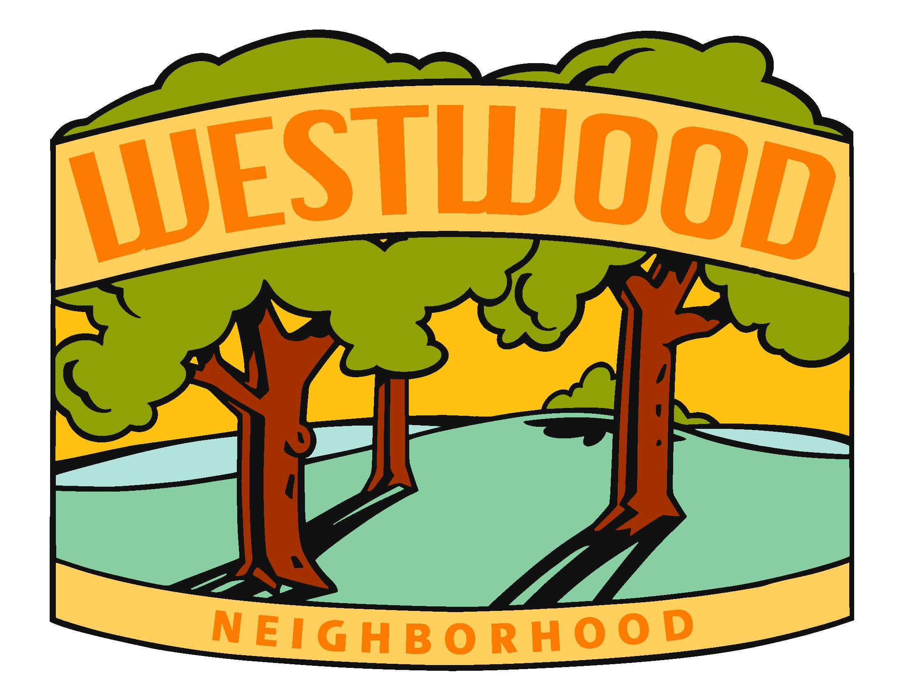
WNA Board Meeting Agenda
Monday, April 19th, 2021

Location: Virtual Zoom Meeting @ 7:30pm

Board Members:

- Diane Kuhn, President
- McKenzie Glazebrook, Vice President
- Sarah Gusse, Treasurer
- Anthony Udrovich, Newsletter

- Michelle Gartner, Secretary
- Vicki Sehgal, Membership Chair
- Vicki Heiken, Block Captain Chair
- Kim Corbin, Comm/Social Chair
- Ed Truslow, Past President

Meeting called to order by Diane Kuhn at 7:3pm.

- Secretary Report
  - Review of last Meeting Notes and action items (1/19 & 3/11). Motion to approve the Secretary Report by Vicki Sehgal, Seconded by Sarah Gusse & Approved
  - Other

- Treasurer Report (Sarah Gusse)
  - Current Report Motion to approve the Treasurer Report by McKenzie Glazebrook, Seconded by Anthony Udrovich & Approved
  - Membership Down (120 members) & expenses are up (does not reflect the ~$2k for the WNA signs). Generally get more members after quarterly newsletters or during in person events. If we don’t send a newsletter soon, promote by sending email with membership list.
  - Move money from PayPal to West Bank? Action Item: Sarah checking on if there is a minimum required to remain in Paypay and if there is any additional fees
  - $180 for COVID relief funds returned to Melanie McQueen
  - $40 for COVID relief funds from Hetherington’s to be donated to the Food Bank of Iowa
  - $100 for Mural Painting from 53rd Street Neighbors. (see feedback from Mandelbaum below). Action Item: Diane will confirm if Michelle had already contacted Laura and if she would speak with the Roosevelt Art Teacher (if she hasn’t, someone else will reach out)

- Primary Business
  - Almost Spring Social Recap
    - ~ 60 people on line (including guests) with a total of 186 drinks and pizza purchased (96 pizzas total)
    - Good feedback on the event (good food, good entertainment)
    - Forgot to extend invite to pick up food to the music and speakers
    - Action Item: Diane to send pictures to Anthony to use in next newsletter (complete)
    - Should WNA make a donation to Waveland Trolly Loop Project/Monument? No (allowing individual contributions to be made)
  - Cache In Trash Out / Walnut Creek Clean Up Recap: ~30 volunteers, picked up 1 ton of trash! Action Item: Diane to send pictures to Kim for FB and Anthony for newsletter (complete)
  - Additional 2021 Events & Meetings
- Summer Event:
- Location: targeting in person at Sylvian Theater (social distancing & mask wearing encouraged) Action Item: Diane is following up with Parks & Rec to confirm the theater is considered part of our 1 free rental for helping with the creek clean up & to confirm available dates
- Date -target 8/1 or 8/29 – time may be 5-8:30 or earlier (lunch time) depending on date
- Entertainment – live music but no balloons. Possible kids activity through DSM art center, library or Mainframe Studios. Action Item: McKenzie to see if we can secure a band close to the $400 rate we’ve paid in the past & Diane will reach out to friends’ band on amount they would charge. TBD on who will reach out to kids activity.
- Food/Drink – concerned with food trucks with lines. Action Item: McKenzie to research options for boxed food (e.g. Palmers, Panera, Pickerman’s, Manhattan Deli – with a focus on somewhere with dessert)
    - Meet the candidates. Local elections in 2021 and candidates have been reaching out to speak to our neighbors. Recommendation to include with Summer event and have candidates set up a table or space where they can talk with neighbors about their platforms. May not have them speak to the group (would band share microphones if it’s sanitized?). Candidates who have reached out:
      - Josh Mandelbaum (our ward, city council)
      - Justyn Lewis (at large city council)
      - Supervisor Connolly (Polk County Board of Supervisors)
    - Halloween Hunt. Discussed this isn’t necessary go forward unless Beggars Night is limited. If we do again, work to make it easier to distribute goodie bags (have them stop by a location to pick up their treat), and potentially adjust to just a full size candy bar.
    - Annual Meeting – targeting 10/21 or 11/11 to avoid DSM school break and election day.
    - Replacement for Decorating Contest? Holiday Hunt? Other Options Action Item: think about any other event to replace the decorating contest.
  - Spring & Summer Newsletters.
  - If the Summer event is 8/1, do a combined Spring/Summer Newsletter. If Summer event is 8/29, complete 2. Investigate if Spring newsletter can be 2 page (just front/back)
  - Topics:
    - Spring Social recap, Walnut Creek Clean Up recap, President’s Letter (if room), membership list, anticipated events, event center on grand, road closures (Ingersoll between 42nd & Polk - 4/19 – 11/15; Grand Ave between 1st & 4th streets in WDSM from 4/19 -November), possible 17 year Cicadas. Need to call out for block captains (Post’s route on 58^{th?})? Action Item – Diane working to confirm if Events Center is being built on Grand, and whether Vicki H knows if we have any block captains that officially need to be replaced.
    - Do we allow advertising in our newsletter? We allowed and charged in the past, but someone would need to track who has paid, size, and ensure inclusion in the newsletter. Past issues included forgetting to include advertising and not sending all 4 newsletters (if someone paid for X number and didn’t get that in that year). Also concerns of who can advertise (only local businesses, local business owners, etc). One of our residents who is a paid member asked for advertising. He indicated the first Friday of the month is an open house at Mainframe Studios here he has studio space. Action Item: Sarah will reach out and advise we’re not including advertising today, but if he would like to write up something we could email it out.
    - Timing: if we do 2 newsletters, need to draft the Spring newsletter by 4/23 so it dropps early/mid May. Target finalizing 2nd newsletter to drop first of august to give time for food sign up. If we do 1 combined newsletter, would need to drop in early/mid July. Action Item: Diane to confirm open dates of Sylvan Theater with Parks and Rec by EOW.

- Other Business
  - ETA on Westwood signs – We are limited to 8 signs (but more may be hung if not major roads). Vicki needs to provide a map for them to hang the signs.
  - Listing local business on our website – we did not do given lack of interest (only 3 people responded).
  - Mailchimp updates. Good open and click rates (41% open, 5% click for Cache in Trash out email. 56% open and 10% click for the previous email. Holiday contest 74% opened)
  - Neighborhood issues
    - Kid walking home from Merrill and taking the cap off the Gusse’s fence post. After posting a sign that they had security cameras, the issues stopped.
    - People are targeting trucks and SUVs to steal their catalytic converters (include in email communication)
    - Reminder for neighbors to lock their doors (trucks/cars gotten in to but thieves move on when doors locked).
  - Other
    - Communications
      - Ironman in DSM 6/20 (road closures on 63rd/park/waterworks park biking/driving trails ~4am-6pm, but not immediately impacting our neighboorhood) – future notification
      - Monthly Parks & Rec updates – Action Item: Diane to send to Kim to include in the next email update (note we can send 4/22 Earth Day and recommend additional sign up opportunities) - completed
      - DSM Sustainability Task Force - (1st & 3rd Wed of the month at 5:30) – next meeting on the 21st of April, but could wait until next month’s meeting.
      - Church event – Kim will be sending email about call out for elderly residents who need help with lawn work.
      - Garlic Mustard is starting to bloom, try to remove now before the plat seeds (not native to Iowa and is very invasive impacting our undergrowth.
      - Upcycle for honeysuckle (is the Blank Park Zoo still taking honeysuckle for their animals?)

- Parking Lot (discuss if time)
  - Replacement for Decorating Contest?
  - New to the neighborhood
  - Membership – Lifetime Membership Options
  - Updating signors at WestBank (future action item - currently Sarah and Diane)

- Next Meeting - 6/7 – 7:30 in person @ McKenzie or Kim’s patio (Virtual back up).

Meeting adjourned 9:50

Feedback on art murals along the bike path from Josh Mandelbaum:
First, if there is general concern about graffiti popping up in the neighborhood, you can contact Jody Rouse (JLRouse@dmgov.org or 515-248-6331), and she can assist with getting the graffiti removed.
As to the idea of a mural, there are several options.
- A permit is no longer required for murals or similar art on private property which is installed by the owner or with the owner’s permission. Advertising and signage are regulated under the Zoning Ordinance.
- There is a process for evaluating requests to place murals on City property, which usually starts with review by the department(s) responsible for the City property which is the subject of the request. If the department(s) do(es) not object to having art installed on the site, the request is reviewed by the City Manager’s Office with input from the Greater Des Moines Public Art Foundation (PAF). PAF reviews and advises the City on art to be placed on City property. Shay Willis in the City Manager’s Office liaison to the PAF. The key next step will be for the neighborhood to identify the best location.
  - I’d start with Shay Willis on this. Her contact info is SEWillis@dmgov.org or (515) 283-4037
  - Ben Page is the Parks Director (BRPage@dmgov.org). When I asked him about it, he suggested working with the Public Art Foundation to identify a location. I think his preference is non-park land. I think the parks department tends to be a little reluctant about public arts projects because they get a large number of requests and there has been issues with maintenance in the past. Their solution is a general policy against these type of projects.
  - The contact for the Greater Des Moines Public Art Foundation is Director Jessica Rowe mjrowe@dsmpublicartfoundation.org
- Placement of art on City property requires a written agreement in the form of a short term license or longer term license agreement that goes to City council for approval. In all cases, the citizens or entity installing the art are responsible for maintaining and removing the art.

