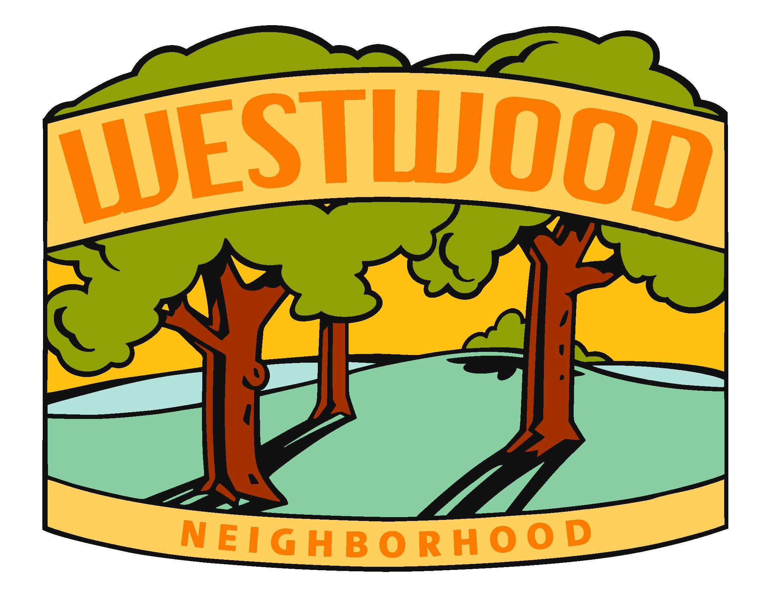
WNA Board Meeting Agenda
Tuesday, September 28th, 2021

Location: Kim’s (329 58th St) @ 7:00pm

Board Members:

- Diane Kuhn, President
- McKenzie Glazebrook, Vice President
- Sarah Gusse, Treasurer
- Anthony Udrovich, Newsletter
- Michelle Gartner, Secretary
- Vicki Sehgal, Membership Chair
- Vicki Heiken, Block Captain Chair
- Kim Corbin, Comm/Social Chair
- Ed Truslow, Past President

Called to order at 7:11 by Diane.

- Secretary Report (Michelle Gartner)
  - Review of last Meeting Notes and action items (6/7)
  - Emails
  - Other
  - Action Item: Diane – follow up with mural painting people.
  - Action Item: Michelle will look again through emails to find Laura.
  - Action Item: Sarah will look through membership contacts for Laura.
Motion to approve and seconded.

- Treasurer Report (Sarah Gusse)
  - Current Report
146 members. $2700 in PayPal, $3600 in West Bank.
  - Other
Report transitioning to new board member.
Motion to approve report, seconded by McKenzie.

- Primary Business
  - Board Members Reelections
Treasurer - Steve C. is on board to be on the board.
Everyone else up for reelection.
  - 2021 Events & Meetings
- Summer Event Recap/Feedback
$800 for band ($700 plus tip)
$919.11 for ice cream
$155 for pop up games
Space?
2 – 21/2 hours max for time
Special Guests
Thinking back to Jay Spence Shelter.
Mike Moody’s band for next year?
- Halloween Hunt?
Have the signs already. Anthony can make up a map.
- Annual Meeting (11/11): Location/Time; Agenda; Communication
Diane – Welcome.
Introduction of current board
Block Captains
Police Liasion
Polk Co Attorney
Parks and Rec (Focus on Wild animals)
Virtual meeting again this year. Chili options for pick-up. Gateway, The Station, Star Bar or Palmers? Action Item: McKenzie will check into options.
Date: Thursday, November 11th
- Replacement for Decorating Contest?
Wreaths added to poles that line Grand? Action Item: McKenzie will look into.
Candles in windows
Food Drive (for families, pets in Feb. 2022?) – Action Item: Kim will email Iowa Food Bank
Backpack Buddies? – Action Item: Kim will look into.
  - Fall Newsletter: Timing; Topics; Print Distribution/Email/Webpage
Timing: Distribution around 10/22
Print before 10/15 start
Copy by 10/13
Topics: School board and city council members. Blurb about voting and possible candidate corner.
Links to candidate websites. Subject to editing for space considerations. 40 characters plus their website information. Disclaimer for candidate info. Info needed by the 8th.
Membership List
Summer Social Recap
Annual Meeting Blurb
Board election candidate information. Candidate Corner.
Grand Avenue block captain needed
Possible school fundraisers. Action Item: McKenzie will follow-up
Possible Holiday decorations?
Trim back summer over growth.
  - Candidate Forum?
  - Westwood Signs (Vicki S)
City only allows 8 signs per neighborhood. Possible add to 58th or 59th, only one or take one off of another street. Suggest adding to 58th, instead of 59th (dead end street).
12 new signs plus an old one that was never hung up.
Add sign to 58th.
  - Urban Deer Hunting in Water Works
  - 2022 Events & Meetings
Almost Spring Social? Indoor meeting dependent on Covid at that time.
Creek Clean Up
Summer Social – around when school starts again? Or in July?
October or November Annual Meeting

- Other Business
  - Neighborhood issues
  - Other

- Parking Lot (discuss if time)
  - New to the neighborhood
  - Membership – Lifetime Membership Options
  - Updating signors at WestBank (future action item - currently Sarah and Diane)

- Next Meeting - Action Item: Michelle will check with Steve and then send out a Doodle poll to Board.

Meeting called to a close at 9:06.

