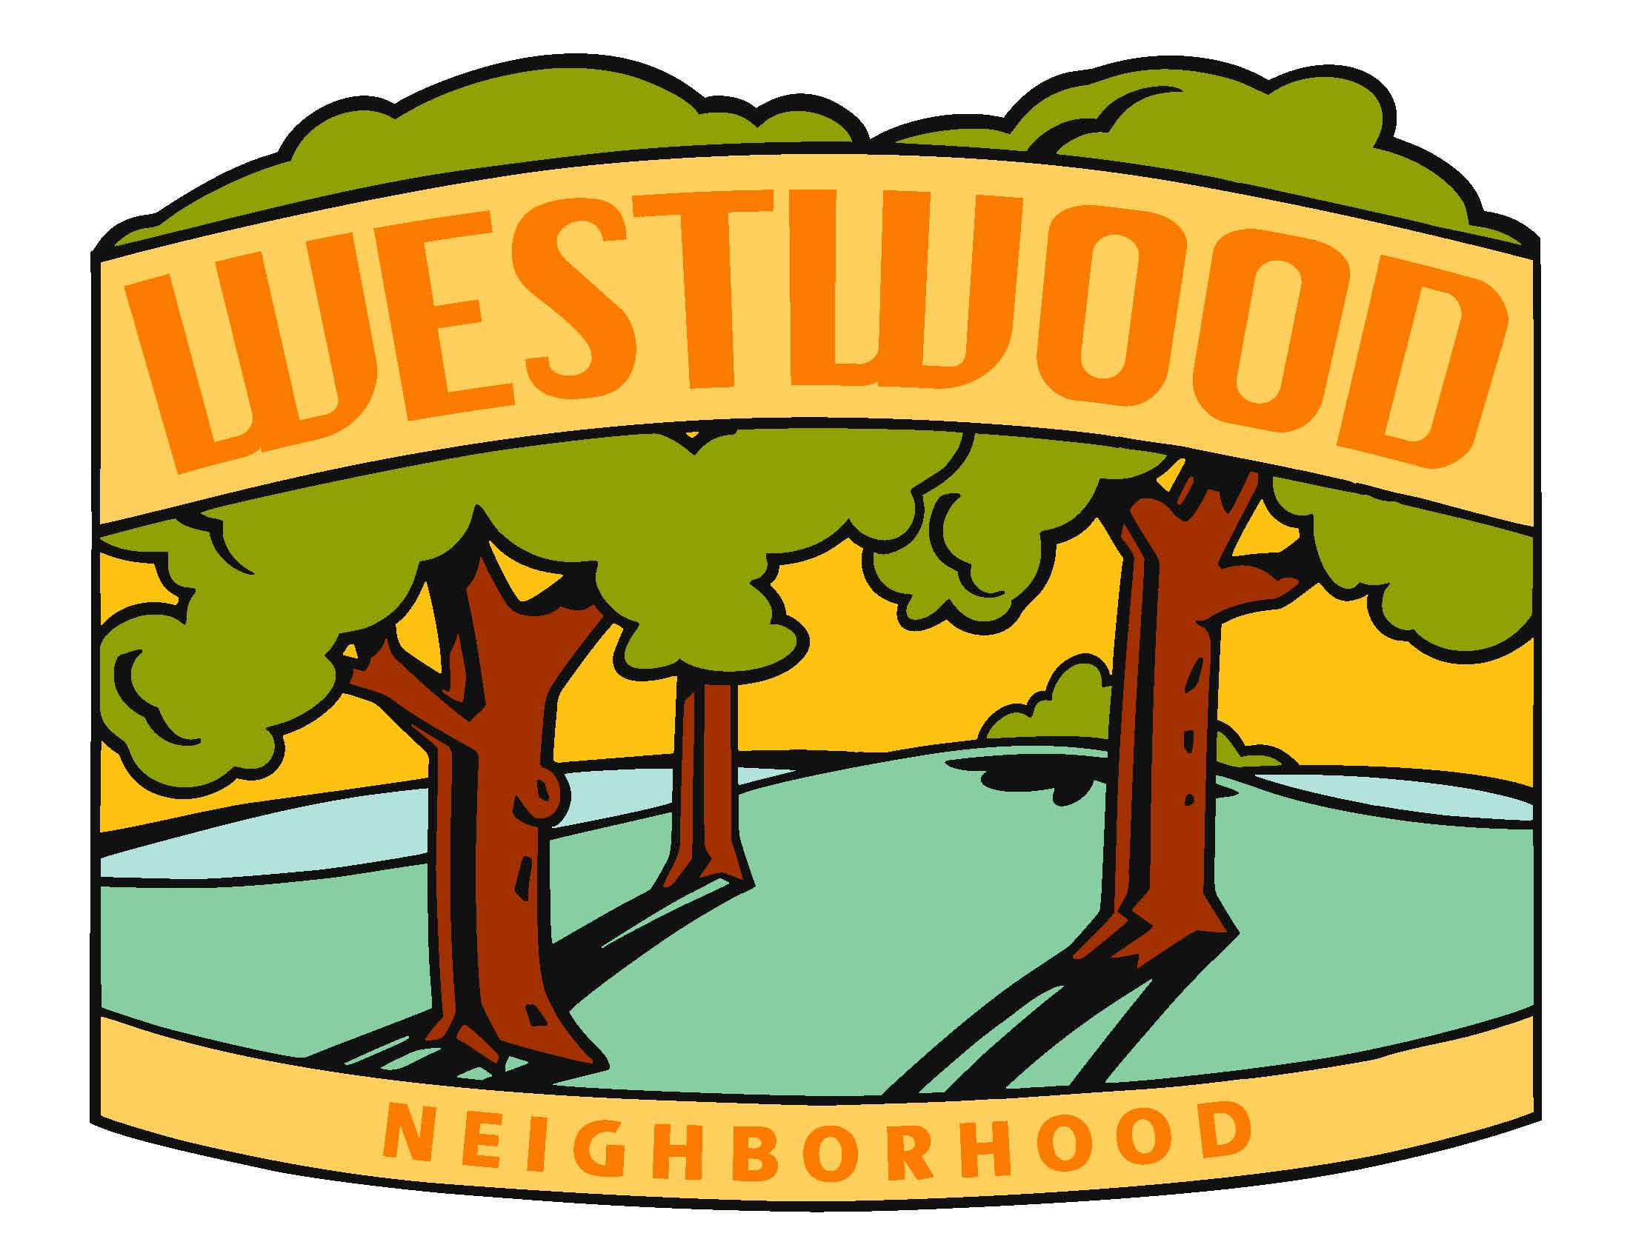
WNA Board Meeting Minutes
Monday, December 6th, 2021

Location: https://us02web.zoom.us/j/84036579171?pwd=bXNRaE5MWWJJclV3dFRNZi9yZlYxUT09
+1 312 626 6799 US (Chicago)
Meeting ID: 840 3657 9171
Passcode: 449664 @ 7:00pm

Board Members:

- Diane Kuhn, President
- McKenzie Glazebrook, Vice President
- Sarah Gusse, Past Treasurer
- Steve Camerona, Treasurer
- Anthony Udrovich, Newsletter
- Michelle Gartner, Secretary
- Vicki Sehgal, Membership Chair
- Vicki Heiken, Block Captain Chair
- Kim Corbin, Comm/Social Chair
- Ed Truslow, Past President

Meeting called to order at 7:04. Welcome to Steve for his first meeting with the WNA.

- Secretary Report (Michelle Gartner)
  - Review of last Meeting Notes and action items (11/11)
  - Other: update on sidewalk on N Valley Drive to 56th scheduled in 2023. Need permission from Railroad and also permits from City.
  - Crosswalk in front of Merrill is not ADA compliant. Josh M gave an update, replacing the signal in 2023, anticipating construction in 2023 with completion in 2024.
  - No update on Ed Truslow’s sewer issue. Sewer backing up in front of his house.
  - Action Item: Michelle will add updates from Josh Mandelbaum to Annual Meeting Minutes.
  - Minute approval, motion made by Kim, seconded by Steve. Motion carries.
  - Meeting feedback: went well. Passionate discussions. A lot of people got the chili, not a lot of attendees though. 36 households ordered chili, 78 bowls total. Will talk more about next year and what we want to do in future meetings.

- Treasurer Report (Sarah Gusse)
  - Current Report
  - 17 new members.
  - Thank you Sarah for all of your hard work and dedication.
  - Transition to Steve & update to West Bank signors (currently Sarah and Diane)
  - Other – Action Items: Sarah will ask West Bank about signers for the account. Secretary and Treasurer, President should not be signing checks. And will also ask Raven about a Debit card for the association.
  - Manage and track membership list, Treasurer report, membership payments and pay pal account.
  - Document passwords, etc. Sarah has made up a list of Treasurer responsibilities.
  - Minute approval, motion made by Steve, seconded by Anthony. Motion carries.
  - Going forward, Sarah will think about other opportunities within the board.

- Primary Business
  - Holiday Food Drive
  - Kim: $351 in donations.
  - Holiday decorating contest spent $200, $100 each for prizes.
  - Use money earmarked for Holiday decorating contest and put it towards the Food Bank donations.
  - Action Item: Kim will send out to the neighborhood that the board is donating towards the Food Bank drive.
  - Donation approval for donating the $200. Motion made by Kim, seconded by Steve. Motion carries.
  - Winter/Spring Social:
Virtual/in-person? Planning for in-person
Date/time: Tuesday or Thursday. February 17th, 22nd, 24th or March 1st. Targeting 2/24
Food/drinks: Will decide after venue is chosen.
Entertainment:
Communication: Newsletter info needed by January 7th. First draft by the 10th or 11th. To Vicki S.by the 21st. To Block Captains by January 28th.
Possible locations: Peacetree, Curate, Foundary, Jasper Winery, “Cub Club”
Action Item: McKenzie will email Peacetree and Foundary to check on venue.
Action Item: Michelle will check into “Cub Club”
Timing: Looking at a Tuesday or Thursday. February 17th, 22nd, 24th or March 1st
Attendees in years past between 50-100.

  - Winter Newsletter:
Timing: Info to Anthony by 1/7. First draft by the 10th or 11th. Printing by the 21st and to Block Captains by 1/28.
Topics: Dues, Spring Social, recap of the Annual Board meeting (elections), Save the Date for the creek clean-up, reminder on neighborhood obligations for snow removal, Food Drive recap, survey on closing 51st, between Grand and Robertson, for Beggar’s Night (if there is space), link to the different services available, new Neighborhood Outreach Coordinator.
Action Item: Diane will send pictures to Anthony from Annual meeting.
Print distribution/email/webpage:

  - Other 2022 Events & Meetings
- Cache In Trash Out – Saturday April 16th (virtual planning meeting 12/15 @ 5:30pm)
If anyone else would like to attend meeting on 12/15, let Diane know. Not sure yet on Covid protocols. Suggestion to return to pre-covid protocols of meeting all together instead of signing up for an area.
Looking for donation cards for “Easter Eggs” that are hidden throughout the clean-up.
Will also have coffee and baked goods, possibly packaged.
- Summer Event
Location: Possibly moving back up to the Jay Spence Shelter, with splash pad and playground.
Action Item: Diane will check on shelter availability.
Date: July 17th, back up date of August 7th.
Food/Entertainment: Action Item: Steve will look into the Nada’s (acoustic only)
- Halloween Hunt
Feedback: continue to have the hunt each year. Communicate it earlier in the newsletter and emails.
- Annual Meeting: Target date in October, possibly the 20th or 27th. Depending on timing with school schedules and hopefully hold in-person.
- Holiday Event:
Do we continue with food drive or do something different? Will discuss further in the future.

- Other Business
  - Westwood Signs (Vicki S)
Action Item: Follow up with Vicki on sign status.
  - Neighborhood issues
  - New Neighborhood Outreach Coordinator – Heather Tamminga
    - Neighborhood Recognition Policy (see pages 3-4 for standards)
    - Help neighborhood associations, point of contact.
  - Funding available via ChangeX (see email) & Polk County Board of Supervisors (from annual mtg)
Can look into for this year.
  - Additional board help: Ben Ulfers (56th St) & Becky Klisares (49th St)
Look into pulling these members in to possibly fill board seats late in 2022.
  - Other – Possibly doing another Blood Drive? Problem in the past that not everyone can donate blood.

- Parking Lot (discuss if time)
  - New to the neighborhood
  - Membership – Lifetime Membership Options
*Continue to table these items.

- Next Meeting
Invite Heather Tamminga to the next meeting with the Board.
Wednesday, February 9th 2022 at 7:00pm
Think about location ideas.

Meeting adjourned at 9:16pm by President Diane Kuhn.

