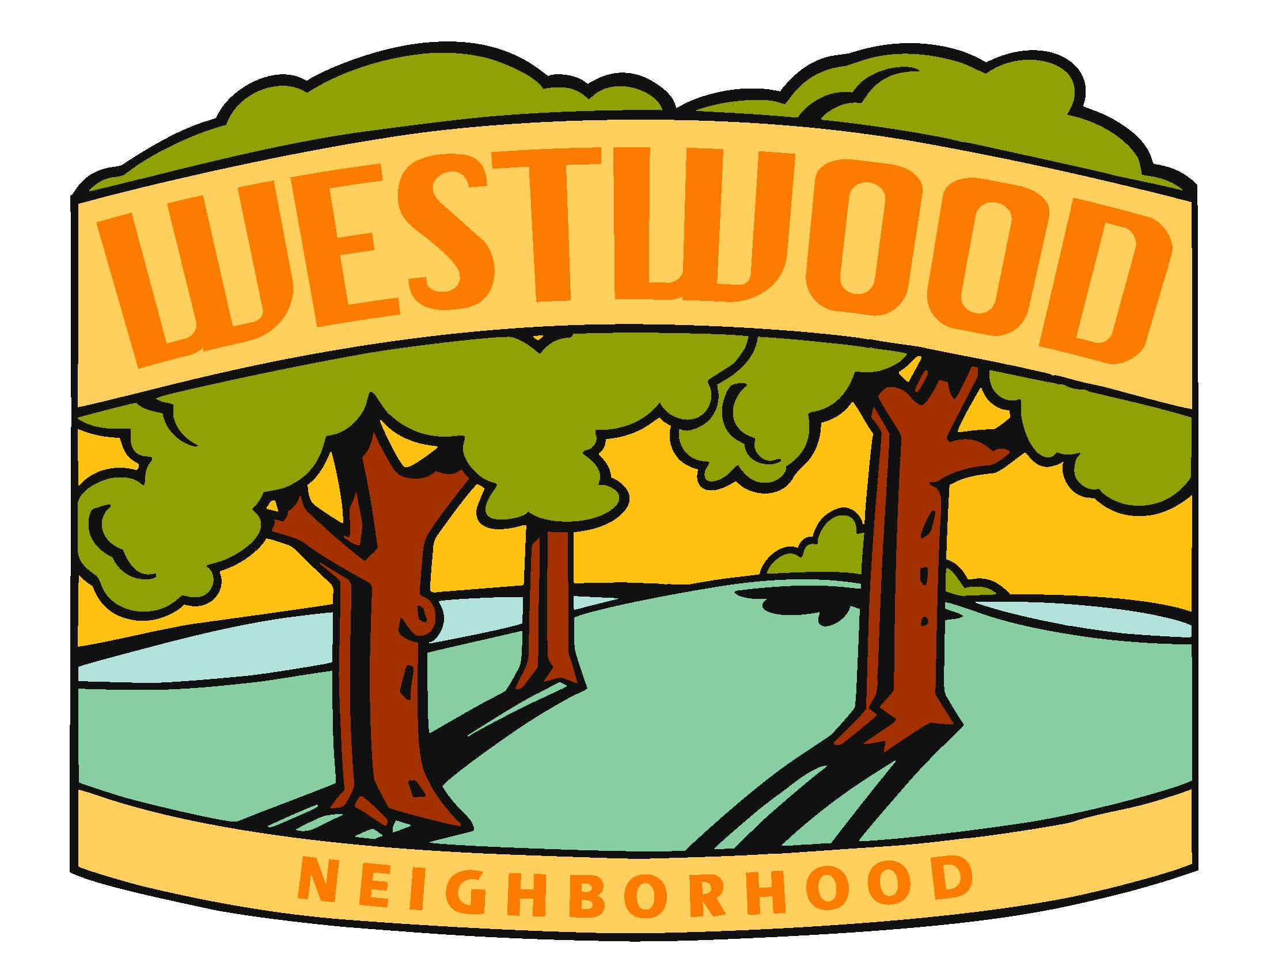
WNA Board Meeting Minutes
Wednesday, May 18th, 2022 @ 7pm

Location: https://us02web.zoom.us/j/89836929366?pwd=UUdCTWd2ckRkU3JQbStiRWk4Nll1dz09
+1 312 626 6799 US (Chicago)
Meeting ID: 898 3692 9366
Passcode: 519219

Meeting called to order at 7:05. Welcome Ben!

Board Members:

- Diane Kuhn, President
- McKenzie Glazebrook, Vice President
- Steve Camerona, Treasurer
- Anthony Udrovich, Newsletter
- Michelle Gartner, Secretary
- Vicki Sehgal, Membership Chair
- Vicki Heiken, Block Captain Chair
- Kim Corbin, Comm/Social Chair
- Ed Truslow, Past President

- Secretary Report (Michelle Gartner)
  - Review of last Meeting Notes and action items (2/7)
  - Other
Action Item: Michelle will send out details regarding the sidewalk program on the May 19th City Planning and Zoning Commission.
Motion to approve secretary report by Vicki and seconded by Kim.

- Treasurer Report (Steve Camerona)
  - Current Report
  - Other: 120 paid members for 2022 as of today, 5/18.
Action Item: Diane will get Steve a receipt for Starbucks gift card from Easter Egg cleanup.
Action Item: Vicki will get Steve printing costs and send an email on what she needs reimbursement wise.
Motion to approve Treasurer report by Vicki seconded by Michelle.

- City Guest Updates (if attending)
Carl Voss, At Large Council Member. On 63rd, a three-year program Creston Ave sidewalk down to the river, across the river and to QuikTrip. Joint project between WDM, DM and DOT. Will greatly help students from Hanawalt that live in Deer Ridge. Most of it is on the West side of 63rd. 5 feet or wider. Cross overs are at two different traffic lights.

Traffic study within neighborhood. Diane did reach out to Heather Tamminga about beginning a study. It would be possible to address how fast people are going and how often. If we are thinking about a traffic study, we should act on it.

In April, DSM fire department had the most female graduates it’s ever had. Hopefully by January 2023 we will be back to the authorized force. Currently, not all the equipment is staffed. Some reasons for staff leaving are retirement, some job changes, etc.
A large police graduate class began in December. Many seasoned police officers are retiring soon.

When City agenda is published. A new city watch area, policing the downtown area is very different with all the events. A deeper dive needs to be done in the Court Avenue area. Policing that area is hard after bar closings.

- Key Accomplishments / Review
  - Donations (Food Bank, School, Parks & Rec): Thank You notes.
Possible visit to tour Food Banks location. Thank you note from Roosevelt principal.
  - Volunteering: Walnut Creek Clean Up 4/16
6-7 gift cards to hand out. Just shy of 90 volunteers to clean up. Ended up filling an entire dumpster of trash. Amy McCreal made treats to pass out during event. Donations from Cheese Shop, Gilroy’s, True Value, etc. Both Girl Scouts and Boy scouts volunteered.
We do have a link if people would like to clean up spaces outside of regular clean up events, support would be given from Parks and Rec. Tires, etc. could be put alongside bike path and the city will come and collect them.
  - Spring Social 3/31 @ Betfred Sports Lounge: feedback/lessons learned
People appreciated that it was later in the year.
Possible babysitting during event.
Look into using Willow on Grand for 2023.
  - Communications:
    - Winter/Spring Newsletter (dropped early March): Thank You Anthony for all his work on the newsletter!!
    - WNA Emails: 3-4 emails going out to the neighborhood. Thank You Kim!!
Possibly send out monthly emails with what is expected for the month. Question: Would we be able to execute?

- Primary Business
  - Summer Social: July 17th @ Jay Spence, 5:30 to 8:00, total budget $3,000: Time, Food (Budget/Menu) & Entertainment (Budget)
Band: $600, plus tip. ($25 per band member for tip) = $700, playing for three hours, which includes set-up. Additional cost: amplifier fee/permit.
Entertainment: Balloon guy is $100 an hour for 2 hours. 6:00 to 8:00.
Face painting? Sidewalk chalk? Activities from the Art Center?
Menu: Hotsy Totsy (5:30 to 7:30) and Totally Rolled Ice Cream (6:00 to 8:00, minimum 50 cups per hour). Budgeting $10 per person for food, and $4 for child size, $5 for small size per ice cream. Action Item: McKenzie will email Hotsy Totsy regarding menu and pricing.
Motion for budget of $3000, with possibility of going to $3500 without board approval. Made by Vicki, everyone approved. Motion passes.
  - Summer Newsletter: timing, topics, print distribution/email/webpage
Topics: Summer Splash, list of neighbors, creek clean-up recap, poll of neighbors if they would like to see 51st St closed for Trick or Treating, news around the neighborhood, reminder of open positions on the board for fall, reminder about speeding or about a possible traffic study.
Action Item: Kim will create poll for closing 51st for Trick or Treat this year.
Action Item: Steve will send Anthony the list of paid members so far for the summer newsletter. Names and an asterisk by new members.
Print: Copy by June 13th
Distribution: June 15th
Email: Summer Social with link
Webpage: Summer Social with link

- Other Business
  - Neighborhood issues:
    - Speeding on 49th
    - Other?
  - Additional Board Help / Membership Review
Ben: Analysis project on which areas of the neighborhood are most represented. Are there things we could build off of to grow membership. Ways to target efforts to grow those areas. As a start, identifying who is a member, who attends what meetings, etc. Identifying trends.
Consensus to provide Ben with the list of members.
Becky: working mainly weekends and is traveling a lot. Would not be available much to help due to current work schedule.

  - Succession: Secretary, VP & President
Will include postings in Summer Newsletter.
  - Other 2022 Events & Meetings
Halloween Hunt: need all new signs. Do we want more signs or less? Begin work after summer splash.
Another Food Drive during the holidays?
  - Other

- Parking Lot (discuss if time)
  - New to the neighborhood
  - Membership – Lifetime Membership Options
Steve asked why this is always kept in the Parking Lot section of the agenda. Need to further investigate and possibly amend bylaws.

- Next Meeting
Wednesday, August 17th at 6:30. Steve’s patio.

Meeting adjourned at 9:16

